Lists
Introduce allocation of memory independently for each element
Describe the concept of a node in a data structure
Present the code for a stack, queue, and doubly linked list
"Use flexible, dynamically allocated data instead of fixed-size arrays." Sutter Alexandrescu (2005).
Elements | Stack | Queue | Doubly Linked List | In-Class Practice | Exercise

A list is a linear data structure that is slightly more flexible than an array. We use lists if the number of elements in the data structure can change. While arrays are primarily suited for managing elements with identical lifetimes and prove cumbersome with differing lifetimes, lists accommodate addition and removal of elements. Adding an element to the beginning or end of an array would involve copying all of the existing elements into a new array. If each element of an array occupies a significant amount of memory or the number of elements is large, this copying operation can be computationally intensive. Lists are optimized to avoid such copying. A list's elements are individually linked to one another and not necessarily stored contiguously in memory.
The elements of a list typically have different lifetimes. Accessing a particular element of a list involves starting with the address of a known element and stepping through the list element by element. The linear ordering of a list ensures that the target element will be reached. More complicated data structures relax this property.
A list links element values to one another through a system of nodes. Each node refers to one piece of data and holds at least one pointer to an adjacent node. The structure links the nodes rather than the data values themselves, which allows for the rapid insertion and removal of elements.
In this chapter, we describe three kinds of lists: stacks, queues and doubly linked lists. We introduce them by starting with a simple chain of elements.

ELEMENTS
A flexible way of allocating memory for a sequence of elements is to allocate it for each element separately. The simplest way to tie the elements together is to link each one directly to the next element in the chain.
Consider a chain of elements that hold integer values. Each element consists of a single int and a pointer to the next element in the chain. The last element in the chain points to the NULL address. We call the element furthest from the NULL address the head and the element closest to the NULL address the tail. We start with an empty chain and allocate memory one element at a time. We add each new element to the head of the chain.
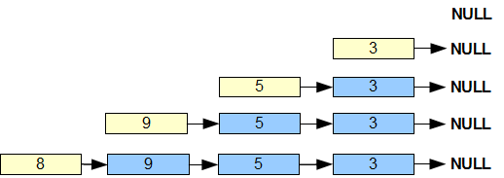
The following code implements this sequential process:
// Lists - Chain of Elements  // chain.cpp  #include <iostream>  using namespace std;  struct Element {  int data;  Element* next;  Element(int d, Element* n) : data(d), next(n) {}  };  int main () {  Element* head = NULL;  // Add one element at a time to the head of the chain  head = new Element(3, head);  head = new Element(5, head);  head = new Element(9, head);  head = new Element(8, head);  // Display elements from head to tail  for (Element* p = head; p; p = p->next)  cout << p->data << ' ';  cout << endl;  // Deallocate one element at a time  while (Element* p = head) {  head = head->next;  delete p;  }  } | 8 9 5 3
A chain displays its elements naturally from head to tail; that is, in reverse order to the order of their addition.
Removing Elements
To remove the first two elements from the head of the chain, we deallocate the memory used by the two elements and reset head to the address of the third element:
// Lists - Removing Elements from a Chain  // elementRemoval.cpp  #include <iostream>  using namespace std;  struct Element {  int data;  Element* next;  Element(int d, Element* n) : data(d), next(n) {}  };  int main () {  Element* head = NULL;  // Add one element at a time to the head of the list  head = new Element(3, head);  head = new Element(5, head);  head = new Element(9, head);  head = new Element(8, head);  // Remove first two elements  Element* remove = head;  head = head->next;  delete remove;  remove = head;  head = head->next;  delete remove;  // Display elements from head to tail  for (Element* p = head; p; p = p->next)  cout << p->data << ' ';  cout << endl;  // Deallocate one element at a time  while (Element* p = head) {  head = head->next;  delete p;  }  } | 5 3
In a chain, we only remove the element at the head. We change the address of the head to that of the element pointed to by the element at the head.
Node
Let us now uncouple the data value from the pointer that holds the address of the next element. We do so by introducing the concept of a node. A node consists of a single data element and at least one pointer to another node. The element itself contains the data value.
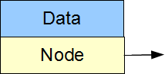
For example,
// Lists - Nodes  // nodes.cpp  #include <iostream>  using namespace std;  class Data {  int data;  public:  Data(int d) : data(d) {}  int out() const { return data;}  };  struct Node {  Data data;  Node* next;  Node (const Data& d, Node* n) : data(d), next(n) {}  };  int main () {  Node* head = NULL;  // Add one nodes at a time to the head of the list  head = new Node(3, head);  head = new Node(5, head);  head = new Node(9, head);  head = new Node(8, head);  // Remove the head node  Node* remove = head;  head = head->next;  delete remove;  // Display elements from head to tail  for (Node* p = head; p; p = p->next)  cout << p->data.out() << ' ';  cout << endl;  // Deallocate one node at a time  while (Node* p = head) {  head = head->next;  delete p;  }  } | 9 5 3
In a chain, a node object contains two instance variables:
- a Data object
- a pointer to the next node
The Node constructor passes the data to its Data member and accepts the the address of the next node. The Dataobject and the pointer to the next node are publicly accessible.
The Data object in turn accepts information through its constructor and exposes that information through its out()query.

STACK
A stack is a list in which each element is added to/removed from the head. In a stack, the last element in is the first element out (LIFO).
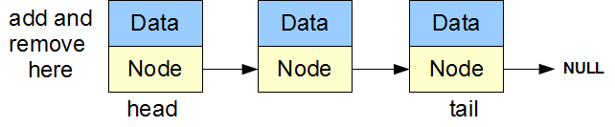
We can rewrite the above example in terms of a Stack class. A Stack object adds an element to its head through the push() method and removes an element from its head through the pop() method.
// Lists - Stack  // stack.cpp  #include <iostream>  using namespace std;  class Data {  int data;  public:  Data(int d = 0) : data(d);  int out() const { return data;}  };  struct Node {  Data data;  Node* next;  Node (const Data& d, Node* n) : data(d), next(n) {}  };  class Stack {  Node* head;  public:  Stack() : head(NULL) {}  ~Stack() {  while (Node* p = head) {  head = head->next;  delete p;  }  }  void push(int d) { head = new Node (d, head);}  Data pop() {  Data data;  if (head) {  Node* p = head;  data = head->data;  head = head->next;  delete p;  }  return data;  }  bool empty() { return head == NULL;}  };  int main () {  Stack s;  // Push Data Onto Stack  s.push(3);  s.push(5);  s.push(9);  s.push(8);  // Remove first Node  s.pop();  // Pop Data Off Stack  while (!s.empty())  cout << s.pop().out() << ' ';  cout << endl;  } | 9 5 3
The only instance variable in our Stack class is a pointer that holds the address of the head node. Given this address, we can locate any element within the object.
Note that our Stack class completely hides the connectivity details from the application.

QUEUE
A queue is a list where elements are added to the tail and removed from the head. A queue operates on a first in, firstout principle (FIFO).
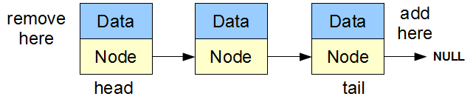
Let us rewrite our node example in terms of a Queue class. Our Queue object adds an element to its head through its push() method and removes an element from its tail through its pop() method.
// Lists - Queue  // queue.cpp  #include <iostream>  using namespace std;  class Data {  int data;  public:  Data(int d = 0) : data(d) {}  int out() const { return data;}  };  struct Node {  Data data;  Node* next;  Node (const Data& d, Node* n) : data(d), next(n) {}  };  class Queue {  Node* head;  Node* tail;  public:  Queue() : head(NULL), tail(NULL) {}  ~Queue() {  Node* current;  while (current = head) {  head = head->next;  delete current;  }  }  void push(int d) {  Node* p = new Node(d, 0);  if (head)  tail->next = p;  else  head = p;  tail = p;  }  Data pop() {  Data data;  if (head) {  Node* p = head;  data = head->data;  head = head->next;  delete p;  if (!head) tail = NULL;  }  return data;  }  bool empty() { return head == NULL;}  };  int main () {  Queue q;  // Push Data onto the Queue  q.push(3);  q.push(5);  q.push(9);  q.push(8);  // Remove First Node  q.pop();  // Pop Data Off the Queue  while (!q.empty())  cout << q.pop().out() << ' ';  cout << endl;  } | 5 9 8
Our Queue class has two instance variables: a pointer to the head node and a pointer to the tail node.
Note that a Queue object displays the values of its data elements from head to tail in the same order as those elements have been added to the queue.

A DOUBLY LINKED LIST
A doubly linked list admits traversal from tail to head as well as from head to tail. It is not restricted to either front-end or back-end addition or removal. We may insert a node before or after any other node and remove any node in the list. This kind of list has a more complicated structure than a stack or a queue.
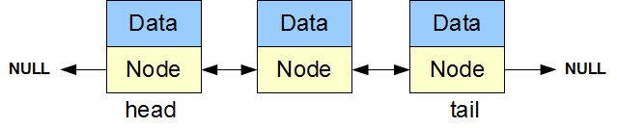
Consider the following example,
// Lists - Doubly Linked List  // doubly.cpp  #include <iostream>  using namespace std;  class Data {  int data;  public:  Data(int d = 0) : data(d) {}  int out() const {  return data;  }  };  struct Node {  Data data;  Node* next;  Node* previous;  Node (const Data& d, Node* n, Node* p) :  data(d), next(n), previous(p) {}  };  class DLList {  Node* head;  Node* tail;  Node* current;  public:  DLList() : head(NULL), tail(NULL), current(NULL) {}  ~DLList() {  while (current = head) {  head = head->next;  delete current;  }  }  void goHead() {  current = head;  }  void goNext() {  if (current) current = current->next;  }  void remove() {  if (current) {  Node* p = current;  if (current == head) {  head = head->next;  }  else {  current->next->previous = current->previous;  current->previous->next = current->next;  current = current->next;  }  delete p;  }  }  bool end() {  return !current;  }  Data get() const {  return current ? current->data : Data();  }  void insertBefore(const Data& a) {  if (current) {  Node* p = new (nothrow) Node(a, current,  current->previous);  if (p) {  if (current->previous)  current->previous->next = p;  else  head = p;  current->previous = p;  }  }  else {  Node* p = new (nothrow) Node(a, NULL, NULL);  if (p)  head = tail = current = p;  }  }  void insertAfter(const Data& a) {  if (current) {  Node* p = new (nothrow) Node(a, current->next,  current);  if (p) {  if (current->next)  current->next->previous = p;  else  tail = p;  current->next = p;  }  }  else {  Node* p = new (nothrow) Node(a, NULL, NULL);  if (p)  head = tail = current = p;  }  }  };  int main () {  DLList r;  // Insert Data  r.insertAfter(3);  r.insertAfter(5);  r.goHead();  r.insertAfter(9);  r.goNext();  r.insertAfter(8);  // Display Data  r.goHead();  while (!r.end()) {  cout << r.get().out() << ' ';  r.goNext();  }  cout << endl;  } | 3 9 8 5
The DLList class contains three instance pointers: a pointer to the head of the list, a pointer to the tail of the list and a pointer to the current element. Each node contains two instance pointers: a pointer to the previous node and a pointer to the next node.
The DLList object positions its current pointer through the goHead() and goNext() methods. We can add an element before or after the current one using the insertBefore() or insertBefore() methods and remove the current element using the remove() method. We can extract the data held in the current element through theget() query.

